|  |  |  |
| --- | --- | --- |
| Name | **Abdulaziz Alhumidi** | |
| Word Count | **Task 1** | **2981 words** |
| **Task 2** | **1046 words** |
| Cohort | **December 2022** | |
| Unit | **5CO02 - Evidence-based practice** | |
| CIPD membership no | **86600955** | |

Table of Contents

Executive summary 3

Introduction 3

Task 1 4

1.1 Evidence Based Practice 4

1.2 Analytical Tools and Methods 6

1.3 Principles of Critical Thinking 8

1.4 Decision Making Processes. 9

1.5 Ethical Perspectives 11

3.1 Measuring Organizational Performance. 13

3.2 The impact and value of people practice. 14

Task 2 17

AC2.1 – With reference to a people practice issue, interpret analytical data using appropriate analysis tools and methods. 17

Table 1 17

Table 2 18

AC2.2 – Present the findings for stakeholders from people practice activities and initiatives. 19

Table 1 19

Table 2 21

AC2.3 - Make justified recommendations based on evaluation of the benefits, risks and financial implications of potential solutions. 23

Recommendation 1 23

Recommendation 2 24

Reference: 25

# Executive summary

This report shows two problems at the organization that need to be addressed thoroughly and solved based on the attached data as evidence. The first problem is the repetitive staff absence which costed the organization 627 total working days and around 64 k Pound. The second problem is the poor managerial skills of manager A in the organization which impact staff performance and well-being.

Staff frequent absence is attributed to burnout and poor work-life balance offered to them by the manager. One recommendation is to offer employees more paid time-off to help them rejuvenate and reduce absence rate. As for poor managerial performance of the manager, she should go through a formal training to close the gap in her managerial skills.

# Introduction

In business, decisions are being made almost every day. With those decisions, organizations might prosper and flourish and might suffer and eventually exit the market. The quality of decision is what determine the fate of the organization. Therefore, decisions need to be studied carefully and backed up with evidence.

This report explains a range of decision-making processes that can help achieve the desired outcomes. Decisions must be backed up with data that serve as evidence of a problem that needs to be fixed. The evidence must be scrutinized and must not be taken for granted. Here comes in critical thinking; the report explains the principles of critical thinking and how those could be applied to evaluate an evidence. Finally, after identifying the problem and making a decision to address it, how could one tell if the decision was the correct one? There are several approaches to gauge organizational performance.

# Task 1

## 1.1 Evidence Based Practice

Evidence based practice is to make the best available decision based on which actions are being performed to reach the required impact (CIPD. 2022). Decision makers must scrutinize the available evidence’s reliability and validity before using it as evidence to back up their decisions. Evidence based practice is an explicit and hard work of collecting and assessing multiple sources of evidence to take informed decision (Briner, 2019).

* *The Rational Model*

The rational model approach to decision making, as opposed to intuitive approach, is a structured approach to decision making in which decision maker seeks several alternatives and elects the best of them (Woerner, 2022). Since it is a structured approach to decision making, it uses consistent steps throughout decision making process to collect and evaluate data and proposes and assesses alternative solutions. It also beaks down the problem into smaller steps considering all aspects of the problem (Brighthubpm.com, n.d.).

Although it sounds great model to use, it assumes that the time is unlimited to collect and scrutinize data and develop and evaluate the alternatives. In today’s business, time is an invaluable asset that cannot be wasted in collecting data and getting perspectives about plausible alternatives for the issue or the decision being made. Moreover, it assumes that the information and data needed to decide are always accessible and can be analyzed (Sefe-mt.com, n.d.).

Amendments of **policies and procedures** is a great decision that should be studied seriously as they impact employees’ wellbeing and hence performance. Using **rational model** here implies that the problem should be clearly identified (changing policies), and a clear goal of changing policies has been set, and different alternatives to those policies have been developed and evaluated. Finally, the best alternative – the best policy among alternatives – has been chosen and implemented.

Another decision-making process in which rational model could be utilized is **high absence levels** in the organization. First the problem needs to be clearly defined and diagnosed. Problem diagnosis is to investigate the root causes underpinning the issue to be able to make an appropriate decision. Then an array of alternative solutions should be developed to face the root cause of the problem. Those solutions are evaluated, and the most viable solution is chosen, communicated to the team, and implemented.

* *Group Decision Making*

Group decision making is when a group of people analyze a problem or take an action collectively whether formally or informally (Gaille, 2016). A group analyzing a problem or deciding on an issue is better than one person as several minds and a pool of knowledge and experience are better than one. The issue is seen from different perspectives which can help in better understanding to the problem and in proposing several solutions.

However, decisions made in a group context lack the accountability. There is no single person is responsible for the outcomes; everyone is responsible (Iedunote.com, n.d.). Moreover, a groupthink might arise in group decision making. Some individuals do not voice their perspectives if they find that most opinions are against their own. As a result, the issue is not thoroughly discussed (Psychologytoday.com, n.d.).

Group decision making can be utilized in **updating outdated L&D practices**, for instance. Managers meet to discuss the viability of the current L&D practices and brainstorm ideas for updating them, then decide the new approach to L&D practices.

## 1.2 Analytical Tools and Methods

* *PESTLE**Analysis*

PESTLE analysis is an analytic tool to the external environment of the organization that help it make informed decisions to utilize opportunities and avoid threats (CIPD, 2021).

PESTLE analysis is a great tool that can help the organization diagnose external issues. It looks for Political, Economic, Sociocultural, Technological, Legislative and Environmental factors, and how they might affect the organization.

For example, if the government imposes a new legislation which might benefit or harm the organization, it can – using PESTLE analysis – scan how might this change affect it and maximize the opportunities and minimize the threats of that new legislation. Imposing new taxes, for instance, would increase financial burden on the organization. In this case, it would develop strategies to cut costs.

It also provides the economic situation outside the organization. That can help organizations to make decisions about expansion if it would benefit from it.

However, PESTLE analysis is not helpful in diagnosing internal organizational issues. It is limited to only the external factors and cannot help in internal factors. It gives a picture about the external economic situation, but it does not provide any insights about financial situation of the organization internally, for instance.

Therefore, PESTLE analysis is used only for scanning the external factors, and it does not give any solution to external issues as well. It is only a tool for collecting information about the external world.

* *Interviews*

Interview is an open discussion between two or more people to share information and collect data and insights.

In terms of current and future organizational issues, interviews are a great tool to help organization’s management to draw a clear picture about people’s perspectives and views about current organizational issue, or a potential future issue. It helps collecting information about the issues as well as proposed solutions for them.

Interviews also help collecting views about challenges and opportunities. The interviewee could be internal, external, primary, or secondary stakeholders of the organization. Getting as many views as possible about the challenges and opportunity is a robust brainstorming exercise based on which a decision could be made.

However, the information collected in interviews are subjective and may also be biased. The interviews collect personal views and perspectives. Attendees may also be hesitant to share their perspectives.

Using interviews as a tool to diagnose organizational issues, challenges and opportunities should be considered carefully and backed up with solid, objective data to support personal views.

## 1.3 Principles of Critical Thinking

Critical thinking is a must-have skill in business and in life in general. It is about thoroughly investigating any piece of information. It is defined as the disciplined and skillful evaluating and judging any piece of information one receives or gathers (criticalthinking.org, n.d.).  The information must not be taken for granted; the source and destination of the information should be studied. Careful consideration should be given to the source validity; the author might have certain interest in providing this information. The destination of the information also should be considered. When receiving a piece of information, one should be aware of their biases and values and challenge them. One might accept or reject a piece of information due to personal preferences.

When constructing an argument, one should think critically about it. Thinking critically about an argument implies presentation of valid evidence and good reasons underpinning them, not emotions and personal preferences. For example, a people professional who are working for a firm and wants to apply certain policy they used to work with before in another organization. They should think critically about the application and validity of that policy in the new workplace not merely because it is within their comfort zone. Judging arguments should be based on data and evidence, not emotions.

When thinking about others’ arguments, that should be done critically. The ideas must not be taken for granted; it must be scrutinized thoroughly and backed up with evidence not personal opinions of the author. Moreover, careful consideration should be given to the author’s credibility. Judging the source and its credibility and whether it is trusted or otherwise is a key critical thinking principle. In addition, the source argument should be based on solid facts not on their personal opinions. Differentiating between mere opinions and sound facts that underpin the argument is a vital critical thinking principle.

## 1.4 Decision Making Processes.

Employee turnover has an adverse impact on organizational performance, and it needs to be dealt with carefully. There are several decision-making processes that could be applied to make a decision to solve that issue.

**Kepner Tregoe process** is an approach to problem solving and decision making. It is based on the rational model to thinking, i.e., it takes a structured way of thinking to solve a problem and make a decision. It uses four steps to solve a problem and reach a solution for it. The first step is to analyze the situation and understand what happened. Next is to understand the cause of the problem and what is not the cause. After that, a decision is made and analyzed. Finally, potential problems that arise from that decision is studied and contingency plans developed (Mulder, 2012).

Applying this approach to ***employee turnover***, the situation should be clearly defined through collecting data and comparing it against a benchmark. Then all possible causes are analyzed and check what is the cause and what is not. After that a decision is made to solve the problem, and the potential problems that might arise are studied and planned to be mitigated.

**Future pacing** is a technique that enables individuals to vision the future of the problem if it has not been solved (negatives) and the future of a decision if it has been made to solve a particular problem (positives) (Edwards, 2020). It could be applied to organizational problems such as ***employee turnover*** to make a decision that tackles that problem. Management could use data, as evidence, of the turnover problem and project it in the future and imagine the organization’s future if it has not been solved. Moreover, decision makers can predict potential outcomes of all proposed decisions and choose the best decision based on future vision of that decision.

**PDCA continuous feedback loop** is another decision-making tool that used to collect data about the problem and decide a solution (Plan), test on a small scale (Do), get the feedback about the decision viability (Check), and finally implement the decision if it proved success (Act). (CIToolkit, 2020). In a problem like ***employee turnover***, this model can be utilized to decide on a solution and **p**lan the course action thoroughly. Next the decision of developing (**d**oing) a retention policy, for example, is implemented to check its viability. After that the **c**hecking step, employee satisfaction survey is collected to benchmark it with previous data. If the policy is successful with employee satisfaction, it is implemented (**a**ct step); otherwise, step one (plan) is repeated and so on.

## 1.5 Ethical Perspectives

The ethical compass of a decision maker informs how and why they make the decisions they have taken. Ethical values can help or deter the decision maker to make a certain decision. There are several theories that deal with what is ethically moral and what is not.

* *Utilitarianism*

Utilitarianism is a theory to describe the morality of actions. The theory states that the actions that bring the greatest happiness for the greater number of people are morally right while actions that bring unhappiness or pain are morally wrong (West H., Duignan B., n.d.).

In the context of decision making, a decision is deemed morally acceptable if it brings happiness to a greater number of people. According to utilitarianism principle a decision is morally right if is increases the well-being of the employees.

Utilitarianism is based on democratic understanding and can be widely accepted. People will easily accept a decision if they perceived that brings the good for the majority. It is hence a widely accepted concept that could be understood by minorities, and hence decision would face less resistance. Therefore, decision maker would decide based on utilitarianism principle.

On the other hand, there are some limitations to utilitarianism. It assumes that the definition of happiness is consistent for everybody; it ignores the individual differences. What makes one happy makes others suffer. As a result, when making a decision that seems to be morally right and brings happiness for the majority, it might be a wrong decision as it does not actually bring happiness to the majority. In addition, it focuses only on consequences rather than the act itself whether it is morally acceptable or not.

* *Altruism*

Altruism is the stance which individual decides to take the option that maximize the social good of the other people (thedecisionlab.com, n.d.). In the context of decision making, the decision being made is chosen to maximize the benefit for other individuals even if it comes with sacrifice from the decision maker. In other words, it is meant to make everybody else happy.

The altruistic approach to decision making is a great one because it attempts to maximize the benefits for everybody, hence increasing their well-being. Decision maker who adopts altruistic approach would make decision for favor of others even if it includes sacrifice from their end. For example, a manager would help a busy subordinate with their family problem despite manager’s other responsibilities. That decision is a personal one and cannot be generalized in corporate world.

However, satisfying everybody is a challenging job and cannot be done easily due to the limited resources. In business context, altruism is not applicable because the organization’s management cannot sacrifice the benefit of the organization due to their accountability.

## 3.1 Measuring Organizational Performance.

There are several methods to measure organizational performance, be it financial of non-financial.

* *Return on investment (ROI) – Financial measure*

Return on investment is a financial metric used to measure how successful a business or project is. ROI is calculated by dividing the net profit of an investment by the cost associated to that investment (Birken, 2022).

ROI is used to assess the viability of a decision and its financial feasibility. In other words, it is used to evaluate past activities. However, it can be used also to predict the profitability of a decision or a project. ROI is evidence that could be utilized for evidence-based practice.

On the other hand, ROI does not give an indication about the growth rate of the investment (Brock, 2021); it only gives an indication about investment by its end, or a prediction when decision is being made about that investment. . In addition, it does not give information about metrics like customer satisfaction and retention or employee well-being and engagement.

* *Customer Satisfaction – non-financial measure*

Another measure to the organization’s performance is the satisfaction of key customers. The value added to them is a great gauge to organization’s success. Customer satisfaction, be they internal or external customers, is a non-financial measure; organization might have bad financial situation due to economic recission while having great customer engagement.

Customer satisfaction is believed to be more important than financial measures. Monetary situations can be fixed when the temporary cause is resolved while customer satisfaction helps organization to reconcile its financial issues. It is a measure for external customers engagement and retention which means high quality service or products are offered by the organization. Internally, employee satisfaction means lower turnover and higher employee performance.

However, organizations cannot call itself successful if they have great internal and external customer satisfaction only without reflection on their net-profit figures. Having engaged customers and high performing employees does not guarantee business survival. Therefore, it cannot measure the profitability of the organization.

The best measure to organization’s’ performance is balanced approach which balance financial and non-financial measures together to a clear picture about performance (e.g., balanced scorecard).

## 3.2 The impact and value of people practice.

People professional have a vital role in an organization because of the value they add and the impact they leave on organization’s strategy. Value is how much something means to someone (Totre, 2014). In people practice context, the value is a tangible or intangible benefit to the organization as a result from HR activity. An impact, on the other hand, is a measurable entity that results from a people practice on the organization or its people.

* *Ex1: Learning and Development Activities*

L&D is one of the core roles of people practice. It is based on measuring the skill gap that employees have and provide the needed training to improve performance. Boosting employees’ performance will not only increase their productivity, but it will also keep them motivated and engaged. The value added due to that activity includes but not limited to employee satisfaction, retention, increased performance, engagement. In addition, organization would be able to fulfill its strategic objectives.

* *Ex2: Recruitment*

Besides L&D activities, recruitment is one of the key roles that people professionals must perform it correctly to add value to the organization and its people. Ineffective recruitment would cost the organization a lot in terms of money and time and lost opportunity. On the other hand, when people professionals do it correctly and accurately, new recruits add their skills and knowledge the existing employees’ skills. The value would be increased performance and productivity and the impact would be higher revenue and lower cost.

* *Method1: Cost-Benefit Analysis*

Cost-benefit analysis is a useful tool that can be used when making a decision on a financial basis. In this analysis, the cost of a certain initiative or activity is calculated and weighted against the potential benefits of that activity. The decision whether to decide on that activity is based on cost-benefit analysis. In recruitment, for instance, the cost of a new hire is weighed against the benefits they can bring to the organization. Building a business case using cost-benefit analysis helps management make the right decision for the organization (Employment Hero, 2023). If the benefits outweigh the costs, then the difference is added value by people practice.

* *Method2: Return on Investment (RIO).*

ROI (Return on Investment) is a business measure to assess the return of an investment relative to the associated cost (Kumbhat, 2020). It can be used in people practice, too, to measure the value or impact added to organization after implementing certain people practice activity. For example, after performing an L&D activity, the return on L&D investment is calculated to measure the impact. However, there are intangible value added such as employee satisfaction and motivation that could not be measured using ROI.

# Task 2

## AC2.1 – With reference to a people practice issue, interpret analytical data using appropriate analysis tools and methods.

### Table 1

Table 1 shows annual absence data for an organization which needs to be analyzed. Based on that analysis recommendations are given to solve the issue.

#### Trends across departments

Pivot table is used to calculate the absence occurrence and the total number of days of absence per department based on which Bradford factor is calculated for each department.

An alternative method to pivot table, there are conditional aggregate functions like sumifs and countifs. They sum and count a range of numbers based on one or more conditions. Here they are used to count the occurrences of absence and total number of days of absence across departments. Based on those, Bradford factor is calculated for each department.

#### Absence by types

Conditional aggregate functions like sumifs and countifs are helpful here to summarize the absence occurrence and total days lost due to absence. Pivot table could be used too.

#### Absence by gender

Again, sumifs and countifs functions are used to conditionally sum and count values based on gender respectively. Moreover, subtotal function is used to average, count, sum, …etc., values for filtered columns.

#### Total days lost through absence

Sum is the function that is used to sum a whole range of number without a condition like sumifs. It is used to sum the total absence days throughout the organization.

#### Annual costs through absence based on a 37- hour week

To calculate the total costs, we need to work out:

1. The hours lost due to employee absence by multiplying the number of lost days by the hours per day.
2. The cost per absence by multiplying employee hours lost (from a) by their hourly rate.

Then we can calculate the total annual cost by summing the values from b.

### Table 2

Table 2 shows the feedback of employees to their manager in a 360-feedback mechanism. It is based on 42 employees who gave the manager a rate from 1 to 5. Using a collection of excel tools like max, index, and match, the higher rating for each item could be worked out. Likewise, percentage could be used in the same manner.

## AC2.2 – Present the findings for stakeholders from people practice activities and initiatives.

### Table 1

#### Trends across departments

Calculating Bradford factors across departments show that all departments need an action except for H&S and strategy and innovation as shown in the figure. Bradford factor above 45 requires an action while 100 and above require disciplinary action (Bradfordfactorcalculator, n.d.).

#### Absence by types

The calculations show that COVID-19 symptoms are the most occuring cause for absence among others. It seems natural during the COVID-19 pandemic which affected all business and sectors and individuals as well.

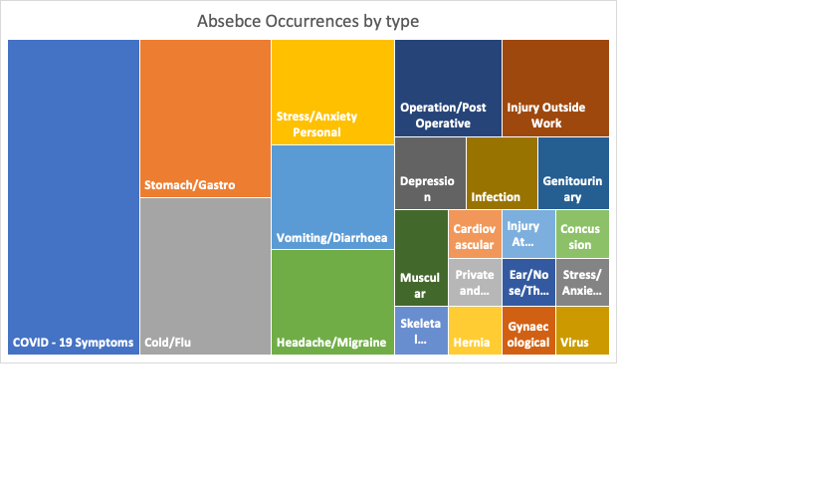

#### Absence by gender

The figure shows the total days of absence of male employees is higher than the total number of days lost by female employees.

#### Total days lost through absence

The data showed that the total number of days lost due to absence was 627 days in total across all departments.

#### Annual costs through absence based on a 37- hour week

Given table 1 for the absence data, the total cost due to absence is £64,111.01. Further analysis should be done to compare the total cost due to absence compared to previous years.

### Table 2

Table 2 that shows the employee feedback to their manager. The results show that employees perceive their manager as a person with good communication skills who recognize their job and deals with them respectively.

However, there are lots of areas of improvement for that manager that include but not limited to resolving conflicts, fairness in applying policies, and supporting their subordinates.

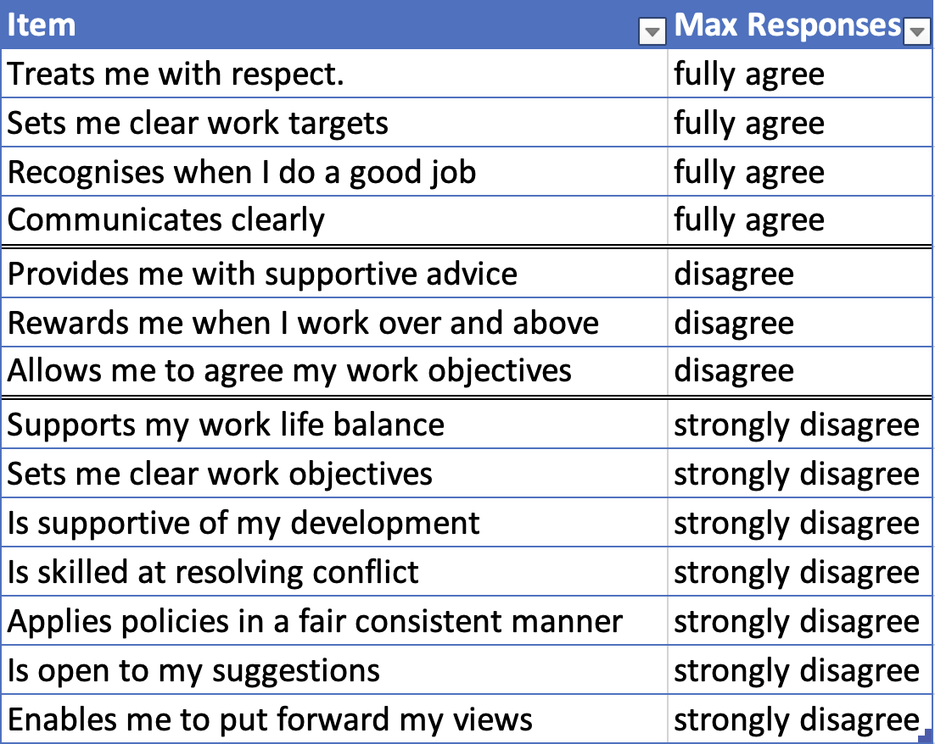

## AC2.3 - Make justified recommendations based on evaluation of the benefits, risks and financial implications of potential solutions.

### Recommendation 1

The data in table one showed high level of absenteeism which costed the company 627 working days lost which resulted in 64 K pound as a financial loss. The higher departments on the list are production and customer service. Moreover, the highest days lost in these two departments was due to private, confidential, stress, and anxiety reasons. The high frequency of absence may be attributed to employee burn out.

One potential solution for that issue is to offer employees more time-off to maintain their work-life balance (Mladenovska, 2022). The benefits of longer rest period for employees are countless that include but not limited to better work-life balance for employees which increases their well-being and hence their productivity. They would also appreciate the initative of the organization and would be more engaged and more productive when they are present. A research shows that time-off increase employees’ focus by 78% and decease burnout by 81% (Frye, 2018)

Despite many benefits of offering more time-off, it is not without its risks. Longer time-off for employees would create staffing problem (Basile, n.d.). Those who are on leave would create a gap in these positions especially those in departments like production which will impact organization’s performance. Lower production would, indeed, adversely impact financial situation of the organization in. In addition, the legal consequences should be scrutinized.

### Recommendation 2

The data in table two shows the performance of a manager with their subordinates. The manager shows poor managerial skills although he treats staff with respect and communicates with them clearly. There are several areas of improvements that need to be fixed with the manager performance. It is recommended for that manager to go through extensive training on managerial knowledge and skills especially critical issues like setting clear working objectives, supporting learning and development, applying policies fairly, and resolving conflicts. These areas are vital for the department to go smoothly.

When the manager has their Personal Development Plan (PDP) and implemented, the subordinates would be more satisfied and engaged. The manager would be able to set clear working objectives for the subordinated and would be able to appreciate the importance of supporting their subordinates with learning and development.

Implementing the above recommendation would stipulate a financial burden. Going thorough official managerial training would cost resources like the manager time and the company’s money. However, it is an invaluable investment that would benefit the whole department when it has a manager with robust managerial skills.

# Reference:

CIPD. (2020) Evidence-based practice for effective decision-making [online]. Factsheet. London: CIPD. Available from: <https://www.cipd.co.uk/knowledge/strategy/analytics/evidence-based-practice-factsheet> [Accessed 6 February 2023].

Briner, R. (2019) The Basics of Evidence-Based Practice. People + Strategy. 42 (1), 16-21. Available from: <https://cebma.org/wp-content/uploads/Briner-The-Basics-of-Evidence-Based-Practice.pdf> [Accessed 6 February 2023].

Woerner, J. (2022) *Steps in the Rational Decision-Making Model* Available from <https://study.com/academy/lesson/the-rational-decision-making-model-steps-and-purpose-in-organizations.html> [Accessed 14 February 2023].

brighthubpm.com (n.d.) *Pros and Cons of the Rational Decision-Making Approach* Available from <https://www.brighthubpm.com/methods-strategies/121817-is-using-the-rational-decision-making-approach-a-rational-choice/> [Accessed 14 February 2023].

sefe-mt.com (n.d.) *The Different Decision-Making Models You Need to Know — And Their Pros and Cons* available from <https://www.sefe-mt.com/careers/blog/different-decision-making-models-pros-and-cons/#decision-making-models> [Accessed 18 February 2023].

Gaille B., (2016) *8 Pros and Cons of Group Decision Making* available at <https://brandongaille.com/8-pros-and-cons-of-group-decision-making/> [Accessed 18 February 2023].

iedunote.com (n.d.) *Group Decision Making: Definition, Advantages, Disadvantages, Strengths, Weaknesses, Techniques* available from <https://www.iedunote.com/group-decision-making> [Accessed 19 February 2023].

psychologytoday.com (n.d.) *Groupthink* available from <https://www.psychologytoday.com/us/basics/groupthink> [Accessed 19 February 2023].

CIPD (2021) *PESTLE analysis*. Factsheet. London: CIPD. Available from: <https://www.cipd.co.uk/knowledge/strategy/organisational-development/pestle-analysis-factsheet> [Accessed 19 February 2023].

criticalthinking.org (n.d.) *Defining Critical Thinking* available at <https://www.criticalthinking.org/pages/defining-critical-thinking/766> [Accessed 23 February 2023].

West H., Duignan B. (n.d.) *utilitarianism* available at <https://www.britannica.com/topic/utilitarianism-philosophy> [Accessed 23 February 2023].

thedecisionlab.com (n.d.) *Altruism* Available from <https://thedecisionlab.com/reference-guide/philosophy/altruism> [Accessed 24 February 2023].

Mulder, P. (2012). Kepner Tregoe Method of Problem Solving explained. Retrieved [insert date] from Toolshero: <https://www.toolshero.com/problem-solving/kepner-tregoe-method/> [Accessed 26 February 2023].

Edwards J., (2020) *Future Pacing and Why You Want to Use It* Available at <https://medium.com/sales-copywriting-content-marketing-with-jim/future-pacing-and-why-you-want-to-use-it-a5fc1078513> [Accessed 26 February 2023].

Continuous Improvement Toolkit (CIToolkit). (2020) *PDCA Cycle*. Available from: <https://citoolkit.com/articles/pdca-cycle/> [Accessed 26 February 2023].

Bradfordfactorcalculator (n.d.) *Bradford Factor* Available at <https://www.bradfordfactorcalculator.com/> [Accessed 10 March 2023].

Totre A., (2014) *What matters the most? Value or Impact?* Available at <https://www.linkedin.com/pulse/20140703181118-450057-what-matters-the-most-value-or-impact/> [Accessed 12 March 2023].

Employment Hero (2023) *How to perform a cost-benefit analysis of hiring* Available at <https://employmenthero.com/blog/cost-benefit-analysis-of-hiring> [Accessed 13 March 2023].

Kumbhat R., (2020) *Human Resources Metrics and ROI* Available at <https://www.linkedin.com/pulse/human-resources-metrics-roi-rekha-kumbhat/> [Accessed 13 March 2023].

Birken E., (2022*) Return on Investment (ROI)* Available at <https://www.forbes.com/advisor/investing/roi-return-on-investment/> [Accessed 14 March 2023].

Brock M., (2021) *What Should You Aim for in ROI? And Mistakes to Avoid* Available at <https://www.entrepreneur.com/business-news/what-should-you-aim-for-in-roi-and-mistakes-to-avoid/376636> [Accessed 14 March 2023].

Mladenovska M., (2022) *How to Reduce Employee Absenteeism: 7 Strategies that Can Help* Available at <https://blog.empuls.io/strategies-to-reduce-employee-absenteeism/> [Accessed 19 March 2023].

Frye L., (2018) *More People Are Taking Time Off, and That’s Good for Business* Avaialbe at <https://www.shrm.org/resourcesandtools/hr-topics/employee-relations/pages/workers-taking-more-vacation-.aspx> [Accessed 19 March 2023].

Basile B., (n.d.,) *Mandatory vacation time for employees: 6 pros and 6 cons* Available at <https://www.insperity.com/blog/mandatory-vacation/> [Accessed 19 March 2023].